Ex.No.10 Use Ghidra to disassemble and analyze the malware code.

Project Objectives
- To provide a hands-on guide to disassembling and analyzing malware with Ghidra.
- To enable readers to recognize common malware functionalities, such as persistence mechanisms, anti-analysis techniques, and network communications.
- To equip users with the skills to interpret low-level assembly code and understand high-level behaviours.

GitHub Repository Components
A GitHub repository for this project could include:
- README.md
  - Overview: Brief description of Ghidra, its installation, and how it is used for malware analysis.
  - Requirements: List of requirements, including Ghidra, a VM setup, and any sample binaries (preferably benign samples or detailed steps to safely acquire controlled malware samples).
  - Project Outline: A breakdown of the tutorial steps, linking to various sections or files within the repository.
- Tutorial Steps (Markdown or Jupyter Notebooks)
  - Step-by-step instructions, broken down into digestible sections, such as:
    - Environment Setup: Instructions on setting up a virtualized and isolated environment.
    - Initial Analysis: How to load a binary into Ghidra, perform auto-analysis, and identify entry points.
    - Function Analysis: Methods for identifying and analyzing critical functions, decompiling code, and using Ghidra’s cross-referencing features.
    - String and Import Analysis: How to locate and interpret strings and imports related to malicious behavior.
    - Advanced Techniques: Dynamic analysis, control flow graphs, custom scripting with Ghidra’s Python or Java capabilities, and obfuscation detection.
- Example Scripts (Python or Java)
  - Scripts to automate repetitive analysis tasks, such as:
    - Extracting and listing all string references.
    - Identifying network-related functions or common indicators of malware.
    - Labeling functions and data segments based on known patterns (e.g., file system manipulation, registry edits).
  - Script Examples: Python or Java code snippets demonstrating API usage in Ghidra (using Ghidra’s Headless Analyzer, for example, for automation).
- Sample Data (Benign Binary or Hex Dump)
  - Due to safety and ethical concerns, include only safe, benign binaries or a hex dump example rather than live malware. This can allow users to learn and practice without the risk of executing malicious code.
  - Sample binaries designed to exhibit typical malware-like behaviors, such as:
    - Executing system calls.
    - Writing to files.
    - Sending network data.
  - Alternatively, a dummy binary generator script that creates binaries with similar structures to malware but without harmful payloads.
- Documentation and Comments
  - Include explanations of the code within each script, detailing what each function does.
  - Inline comments in disassembly views, providing readers with insights into assembly commands, control flow structures, and the decompiled code.
- Report Template
  - A reporting template for documenting findings, which could be in Markdown or PDF format. The template should cover:
    - Summary of Analysis: Brief description of the suspected malware.
    - Function Analysis: Summary of the key functions, their purpose, and the findings.
    - Behavioral Indicators: Summary of malware behaviors, such as persistence, file system manipulation, or network communications.
    - Recommendations: Suggestions on further actions, such as containment, eradication, or further analysis.

Example Repository Structure
plaintext
ghidra-malware-analysis-project/
├── README.md
├── docs/
│ ├── Tutorial_Step1.md
│ ├── Tutorial_Step2.md
│ └── Tutorial_StepN.md
├── scripts/
│ ├── extract_strings.py
│ ├── network_analysis.py
│ └── label_functions.py
├── samples/
│ ├── benign_sample1.bin
│ └── benign_sample2.hex
├── templates/
│ └── analysis_report_template.md
└── screenshots/
├── function_graph_example.png
└── decompiler_example.png

Project Development and Future Work
- Expand Scripts: Continue adding Ghidra scripts to automate complex analysis tasks.
- Community Contributions: Encourage community members to contribute additional benign samples, analysis scripts, and documentation improvements.
- Advanced Topics: Include guides for advanced techniques, such as unpacking obfuscated code, identifying encryption routines, and using the P-Code emulator for runtime analysis.

Output:

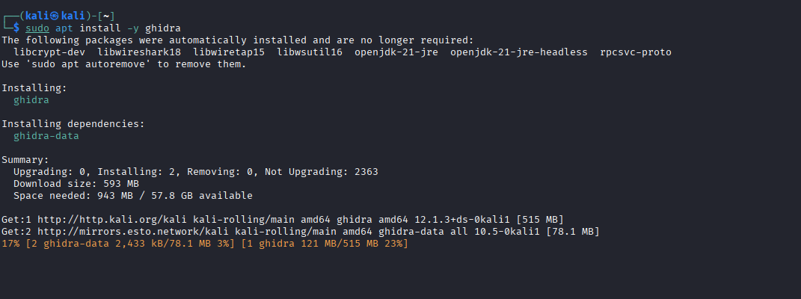
Figure 52: Execution of the apt package manager in Kali Linux to install the Ghidra reverse engineering suite.

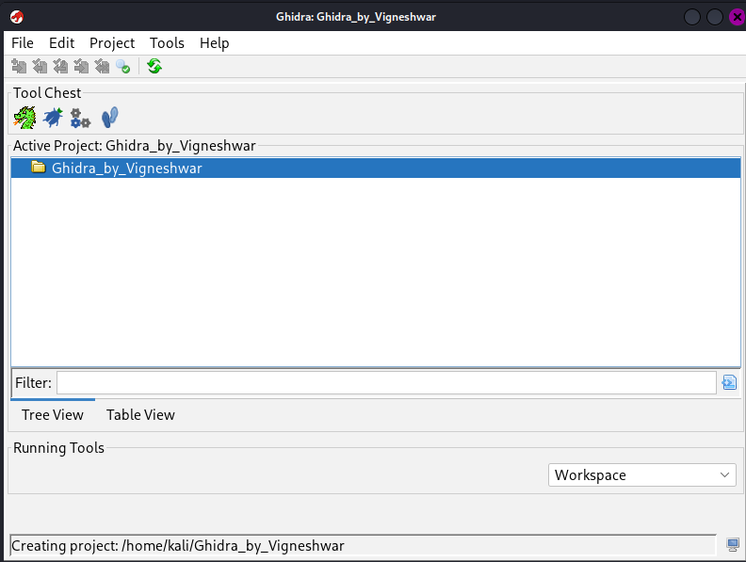
Figure 53: Ghidra project management interface showing the creation of a new active project workspace.

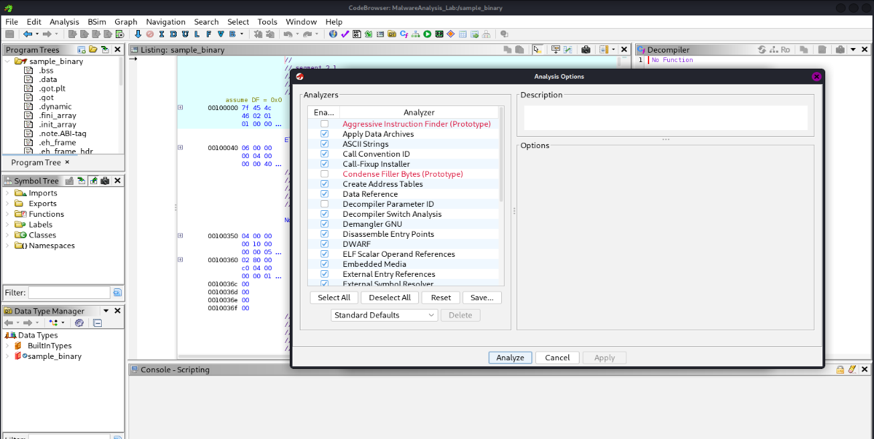
Figure 54: CodeBrowser auto-analysis dialog detailing the various executable analyzers selected for processing the sample binary.

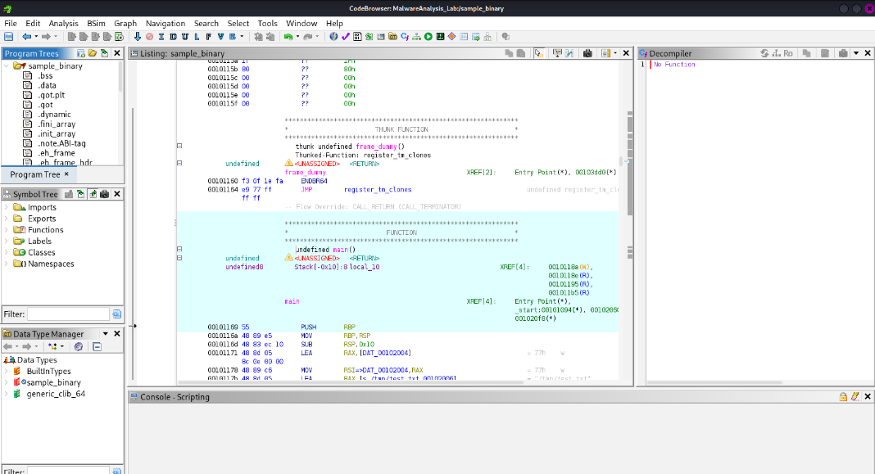
Figure 55: Disassembled assembly instructions and memory addresses for the binary's main function displayed within the CodeBrowser listing view.
Rubricss

Criteria & Marks Assigned | Mark Allotted | Mark Awarded
1. GitHub Activity & Submission Regularity | 3
2. Application of Forensic Tools & Practical Execution | 3
3. Documentation & Reporting | 2
4. Engagement, Problem-Solving & Team Collaboration | 2
Total | 10

RESULT
Ghidra was successfully utilized to disassemble, decompile, and analyze the target binary code. Through automated analysis, string inspection, API import tracking, and decompiler evaluation, the binary's underlying structure and behavioral logic were effectively interpreted.

